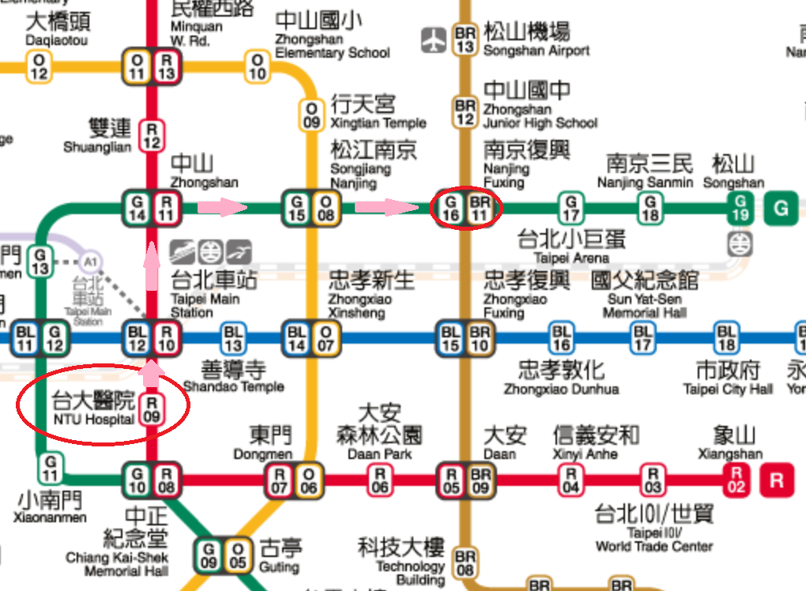

Start from NTU Hospital to Nanjing Fuxing.

The shortest path is illustrated by arrows.

Result:

For invalid input case:

